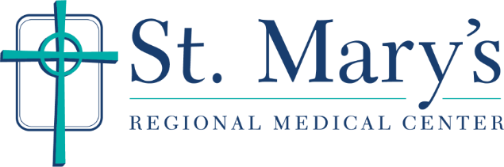
REQUEST FOR MEDICAL RECORDS
For the health and safety of our community and staff, please follow the instructions below to obtain a copy of your medical records:
- If you are requesting records to be sent to your healthcare provider for continuity of care, please call 580-249-3803 with the following information:
  - Your full name, date of birth and a phone number in case the staff have a question.
  - Dates of Service
  - Reports/documents
  - Physician office/hospital

- If you are requesting records for yourself or other reason, please fax or email the completed authorization form (attached or located on the St. Mary’s website www.stmarysregional.com along with a copy of your ID (example driver’s license, government identification card, etc.) to fax number 580-249-3983 or email terri.schultz@uhsinc.com.

- If you are trying to obtain records for someone other than yourself, please call the Release of Information Office at 580-249-3803. They will provide you with the documentation needed to process this request.
We also provide HEALTH RECORDS ONLINE. Please visit www.stmarysregional.com. There will be a tip sheet on how to access your records online.
You may obtain a copy of the HIPAA compliant “Authorization to Release Protected Health Information” form under the “Health Records Online” link.
We apologize for any inconvenience, but under no circumstances do we release any personal information and/or results over the telephone as we are not clinical or designated to interpret any records.

Health Information Management/Release of Information Office
Hours: Monday through Friday, 8:00 a.m.-4:30 p.m.
Phone: 580-249-3803
Fax: 580-249-3983

